MINI PROJECT

ON

**“ DECENTRALISED ACCESS CONTROL WITH ANONYMOUS AUTHENTICATION IN CLOUDS ”**

*A report submitted in partial fulfilment of the requirements for the Award of Degree of*

## BACHELOR OF TECHNOLOGY

**in**

## INFORMATION TECHNOLOGY

**By**

## GUNDETI NISHANTH

## RUTHVIK REDDY

## D. SHIVA PRASAD

## Regd. No. :

## 20BK1A1240

## 20BK1A1226

## 21BK5A1202

**Under Supervision of Mr. SRINIVAS**

**VCUBE SOFTWARE SOLUTIONS PVT.LTD**

**HYDERABAD**

**JUNE 2023**



## Department of Information Technology

## ST PETERS ENGINEERING COLLEGE

( UGC Autonomous)

Accredited by NAAC &NBA,Approved by AICTE & Permanently Affiliated by JNTUH ,Hyderabad Telangana

2020-2024

# ST PETERS ENGINEERING COLLEGE,

# DEPARTMENT OF INFORMATION TECHNOLOGY



**CERTIFICATE**

This is to certify that the “Internship Report” submitted by **Gundeti Nishanth**(20BK1A1240), Ruthvik Reddy(20BK1A1226), D.Shiva Prasad(21BK5A1202) is work done by us and submitted during academic year 2022- 2023, in partial fulfilment of the requirements for the award of the degree of **BACHELOR OF TECHNOLOGY in INFORMATION TECHNOLOGY**, at V CUBE

Software Solutions Pvt. Ltd, Hyderabad.

**MADHAVI MADHAVI**

Assistant professor Assistant professor

Department of internship coordinator Department of IT

# ACKNOWLEDGEMENT

At outset I express my gratitude to the almighty lord for showering his grace and blessings upon me to complete this Mini Project. Although my name appears on the cover of this book, many people have contributed in some form or the other to this project development. I could not have done this Project without the assistance or support of each of the following.

First I would like to thank Mr. Srinivas, VCube Software Solutions Pvt. Ltd, Hyderabad for giving me the opportunity to do an internship within the organization.

I also would like all the people that worked along with me VCube Software Solutions Pvt. Ltd with their patience and openness they created an enjoyable working environment.

First of all, I am highly indebted to **Dr.SRI LATHA**, Principal for giving us the permission to carry out this Mini Project and for the facilities provided to accomplish this internship.

I would like to thank **MADHAVI** , Professor & Head of the Department of INFORMATION TECHNOLOGY, for being moral support throughout the period of the study in the Department.

I am grateful to MADHAVI, Associate Professor & Internship Coordinator, Department of INFORMATION TECHNOLOGY, for his valuable suggestions and guidance given by him during the execution of this Project work.

I would like to thank the Teaching and Non-Teaching Staff of the Department of INFORMATION TECHNOLOGY for sharing their knowledge with us.

GUNDETI NISHANTH

20BK1A1240

RUTHWIK REDDY

20BK1A1226

D.SHIVA PRASAD

21BK5A1202

# ABSTRACT

We propose a new decentralized access control scheme for secure data storage in clouds that supports anonymous authentication. In the proposed scheme, the cloud verifies the authenticity of the series without knowing the user’s identity before storing data. Our scheme also has the added feature of access control in which only valid users are able to decrypt the stored information. The scheme prevents replay attacks and supports creation, modification, and reading data stored in the cloud. We also address user revocation. Moreover, our authentication and access control scheme is decentralized and robust, unlike other access control schemes designed for clouds which are centralized. The communication, computation, and storage overheads are comparable to centralized approaches.

# ORGANIZATION INFORMATION

V CUBES SOFTWARES SOLUTIONS PVT.LTD , is an institute that caters to the needs of students, businessmen and freelancers wanting to learn , improve , explore and soar in their careers .Their corporate office is located in Kukatpally , Hyderabad , India . They were founded with the goal of providing students with training in the world’s most exciting sectors, preparing them for jobs and industries , and preparing them to face competitive challenges . The organization is committed to pure professionalism and making sure that the internship gets completed in the scheduled time . Equal priority was given for both theoretical & practical sessions during the internship training.

## PROGRAMS AND OPPORTUNITIES

1. Offer Training
2. Provide interns with real work assignments.
3. Offer flexible time
4. Had an intern manager
5. Encourage team involvement
6. Showcase intern work through presentations
7. Brainstorming

# METHODOLOGIES

Access control is the process of:

* identifying a person doing a specific job
* authenticating them by looking at their identification
* granting a person only the key to the door or computer that they need access to and nothing more.

## METHODS

Here are some methods of access control:

* [Mandatory Access Control (MAC)](http://www.pcmag.com/encyclopedia/term/46573/mandatory-access-control)
* [Role-Based Access Control (RBAC)](http://csrc.nist.gov/groups/SNS/rbac/)
* [Discretionary Access Control (DAC)](http://www.techopedia.com/definition/229/discretionary-access-control-dac)
* [Rule-Based Access Control (RBAC or RB-RBAC)](https://www.business.com/access-control-systems/rule-based/)

## KEY PARTS OF THE REPORT

1. Distributed access control of data stored in the cloud so that only authorized users with valid attributes can access them.
2. Authentication of users who store and modify their data on the cloud. 3.The identity of the user is protected from the cloud during authentication.
3. The architecture is decentralized, meaning that there can be several KDCs for key management.
4. The access control and authentication are both collusion resistant, meaning that no two users cancollude and access data or authenticate themselves,if they are individually not authorized.
5. Revoked users cannot access data after they have been revoke

**INTERNSHIP OBJECTIVES**

* 1. Gain valuable work experience and knowledge
  2. Develop work habits and attitudes necessary for job success.
  3. Integrate theory and practice.
  4. Explore career alternatives prior to graduation.
  5. Provides opportunities for improvement.

# WEEKLY REPORT OF INTERNSHIP ACTIVITIES

## WEEK-1

* Problem Definition
* Introduction to web development and java
* HTML , CSS , JAVA

## WEEK-2

* Introduction to database server:MYSQL
* Client side and server side architecture
* Installation process

## WEEK-3

* Coding in HTML , CSS
* Server side coding(Backend)
* Creating modules like admin page , home page , user page
* Cloud based information

## WEEK-4

* Implementation
* Testing

# TABLE OF CONTENTS

1. INTRODUCTION 11
2. SYSTEM ANALYSIS 12
3. SYSTEM REQUIREMENTS 14
4. TECHNOLOGIES 15
5. SAMPLE CODE 16
6. OUTPUT SCREENSHOTS 22
7. CONCLUSION 25
8. BIBILOGRAPHY 26

# INTRODUCTION

Research in cloud computing is receiving a lot of attention from both academic and industrial worlds. In cloud computing, users can outsource their computation and storage to servers using the Internet. This frees users from the hassles of maintaining resources on-site. Clouds can provide several types of services like applications , infrastructures , and platforms to help developers write applications . Much of the data stored in clouds is highly sensitive, for example, medical records and social networks. Security and privacy are, thus, very important issues in cloud computing. On one hand, the user should authenticate itself before initiating any transaction, and on the other hand, it must be ensured that the cloud does not tamper with the data that is outsourced. User privacy is also required so that the cloud or other users do not know the identity of the user. The cloud can hold the user accountable for the data it outsources, and likewise, the cloud is itself accountable for the services it provides. The validity of the user who stores the data is also verified. Apart from the technical solutions to ensure security and privacy, there is also a need for law enforcement.

# SYSTEM ANALYSIS

## EXISTING SYSTEM:

* + Existing work on access control in the cloud is centralized in nature. Except and, all other schemes use ABE. The scheme uses a symmetric key approach and does not support authentication. The schemes do not support authentication as well.
  + It provides privacy preserving authenticated access control in the cloud. However, the authors take a centralized approach where a single key distribution center (KDC) distributes secret keys and attributes to all users.

## DISADVANTAGES OF EXISTING SYSTEM:

* + The scheme uses an asymmetric key approach and does not support authentication.
  + Difficult to maintain because of the large number of users that are supported in a cloud environment

## PROPOSED SYSTEM:

* + We propose a new decentralized access control scheme for secure data storage in clouds that supports anonymous authentication.
  + In the proposed scheme, the cloud verifies the authenticity of the series without knowing the user’s identity before storing data.
  + Our scheme also has the added feature of access control in which only valid users are able to decrypt the stored information.
  + The scheme prevents replay attacks and supports creation, modification, and reading data stored in the cloud.

## ADVANTAGES OF PROPOSED SYSTEM:

* + Distributed access control of data stored in the cloud so that only authorized users with valid attributes can access them.
  + Authentication of users who store and modify their data on the cloud.
  + The identity of the user is protected from the cloud during authentication.

# SOFTWARE REQUIREMENT SPECIFICATIONS

## Hardware Requirements:

* + - System : Pentium IV 3.5 GHz or Latest Version.
    - Hard Disk : 40 GB.
    - Monitor : 14’ Colour Monitor.
    - Mouse : Optical Mouse.
    - Ram : 1 GB.

## Software Requirements:

* + - Operating system : Windows XP or Windows 7, Windows 8.
    - Coding Language : Java / J2EE (Jsp,Servlet)
    - Data Base : My Sql Server
    - Documentation : MS Office
    - IDE : Eclipse Galileo
    - Development Kit : JDK 1.6

# TECHNOLOGIES

* + HTML , JAVA
  + DATABASE - MYSQL
  + APACHE TOMCAT SERVER
  + LIBRARIES
  + CLIENT - SERVER ARCHITECTURE (FRONTEND AND BACKEND
  + PROTOCOL - API , HTTP
  + DATA FORMAT - XML

# SAMPLE CODE

<!DOCTYPE html PUBLIC "-//W3C//DTD XHTML 1.0 Transitional//EN" ["http://www.w3.org/TR/xhtml1/DTD/xhtml1-transitional.dtd">](http://www.w3.org/TR/xhtml1/DTD/xhtml1-transitional.dtd)

[<html xmlns="http://www](http://www.w3.org/1999/xhtml).w3.or[g/1999/xhtml">](http://www.w3.org/1999/xhtml)

<head>

<meta http-equiv="Content-Type" content="text/html; charset=utf-8" />

<title>Sport Center - free website template</title>

<meta name="keywords" content="free web template, sport center, CSS, HTML, 2 columns" />

<meta name="description" content="Free Website Template - Sport Center" />

<link href="templatemo_style.css" rel="stylesheet" type="text/css" />

</head>

<body>

<div id="tmeplatemo_container">

<div id="templatemo_menu">

<ul>

<li><a href="#" class="current">Home</a></li>

<li><a href="#">About</a></li>

<li><a href="[http://www.templatemo.com](http://www.templatemo.com/)" target="_parent">Templates</a></li>

<li><a href="[http://www.koflash.com](http://www.koflash.com/)" target="_parent">Gallery</a></li>

<li><a href="#">Members</a></li>

<li><a href="#" class="last">Contact Us</a></li>

</ul>

</div> <!-- end of menu -->

<div id="templatemo_header_01">

</div> <!-- end of header -->

<!-- ** OR

<div id="templatemo_header_02">

<div id="site_title">Sport Center<span>Your tagline goes here</span></div>

</div> end of header -->

<div id="tmeplatemo_content">

<div id="templatemo_side_column">

<div class="top"></div>

<div class="header_01">News &amp; Events</div>

<div class="news_event_section">

<div class="header_02">Lorem ipsum dolor sit amet</div>

<img src="images/templatemo_image_01.jpg" alt="photo one" />

<p>Donec ut felis libero. Nunc vel libero libero, in dignissim urna. Praesent tempor, arcu at egestas vestibulum, lorem elit viverra velit, sit amet gravida ligula ante et sem.</p>

<div class="button_01"><a href="#">Read more</a></div>

</div>

<div class="news_event_section">

<div class="header_02">Integer in magna nec lacus</div>

<img src="images/templatemo_image_00.jpg" alt="photo two" />

<p>Suspendisse potenti. Aliquam erat volutpat. Mauris tempus massa vitae sem posuere pharetra. Donec eget neque erat, ac venenatis libero. Cras consequat pharetra sem ut imperdiet.</p>

<div class="button_01"><a href="#">Read more</a></div>

</div>

<div class="cleaner"></div>

<div class="bottom"></div>

</div> <!-- end of side column -->

<div id="templatemo_main_column">

<div class="header_01">Welcome to Sport Center</div>

<div class="section_w480">

<div class="image_wrapper fl_img"><img src="images/templatemo_image_02.jpg" alt="photo three" /></div>

<p class="em_text"><a href="<http://www.templatemo.com/page/1>" target="_parent">Sport Center Template</a> is a free layout provided by <a href="[http://www.templatemo.com](http://www.templatemo.com/)" target="_parent">templatemo.com</a> for everyone. You may use this template in your websites. Credit goes to <a href=``http://www.photovaco.com'' target=``_blank''>Free Photos</a> for photos used in this template.</p>

<p>Lorem ipsum dolor sit amet, consectetur adipiscing elit. Integer vitae metus quis libero consectetur egestas. In hac habitasse platea dictumst. Suspendisse tempus, metus in semper accumsan, dolor purus imperdiet magna, a iaculis quam justo quis purus.

Etiam ut erat enim, et aliquet orci.</p>

<div class="button_01"><a href="#">Read more</a></div>

</div>

<div class="section_w480">

<div class="header_01">Our Activities</div>

<p>Lorem ipsum dolor sit amet, consectetur adipiscing elit. Integer vitae metus quis libero consectetur egestas. In hac habitasse platea dictumst. Suspendisse tempus, metus in semper accumsan.</p>

<div class="margin_bottom_20"></div>

<div class="section_w160 fl">

<div class="image_wrapper"><img src="images/templatemo_image_03.jpg" alt="image" /></div>

</div>

<div class="section_w270 fr">

<ul class="content_list_01">

<li>Cras urna nisi, porta et gravida blandit, laoreet ornare nunc.</li>

<li>Donec tincidunt sem eget velit cursus sit amet ullamcorper mi vulputate. </li>

</ul>

<div class="margin_bottom_20"></div>

<div class="button_01"><a href="#">Read more</a></div>

</div>

<div class="cleaner"></div>

</div>

</div>

<div class="cleaner"></div>

</div> <!-- end of content -->

<div id="templatemo_footer">

Copyright © 2048 <a href="#">Your Company Name</a> | <a href="[http://www.iwebsitetemplate.com](http://www.iwebsitetemplate.com/)" target="_parent">Website Templates</a> by

<a href="[http://www.templatemo.com](http://www.templatemo.com/)" target="_parent">Free CSS Templates</a>

<div class="margin_bottom_20"></div>

<a href="<http://validator.w3.org/check?uri=referer>"><img style="border:0;width:88px;height:31px" src="<http://www.w3.org/Icons/valid-xhtml10>" alt="Valid XHTML 1.0 Transitional" width="88" height="31" vspace="8" border="0"

/></a>

<a href="<http://jigsaw.w3.org/css-validator/check/referer>"><img style="border:0;width:88px;height:31px"

src="<http://jigsaw.w3.org/css-validator/images/vcss-blue>" alt="Valid CSS!" vspace="8" border="0" /></a>

</div> <!-- end of footer -->

</div> <!-- end of container -->

<div align=center>This template downloaded form <a

href=['http://all-free-download.com/free-website-templates/](http://all-free-download.com/free-website-templates/)'>free website templates</a></div></body>

</html>

# OUTPUT SCREENSHOTS

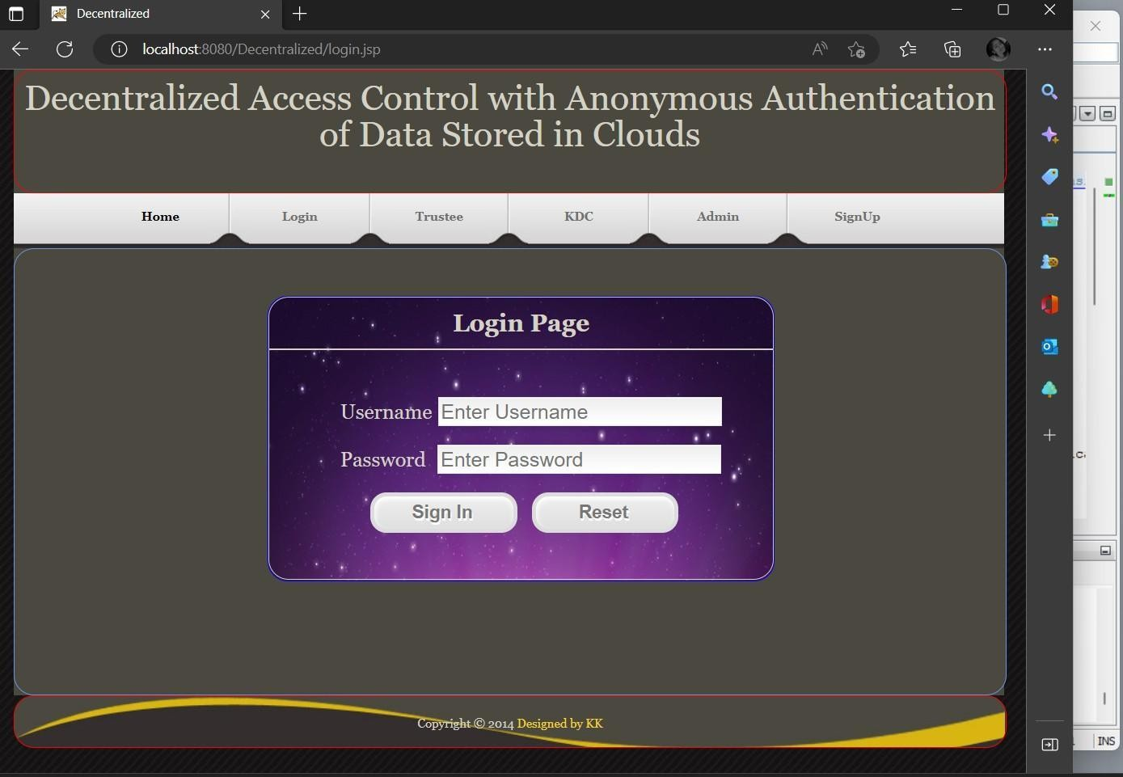

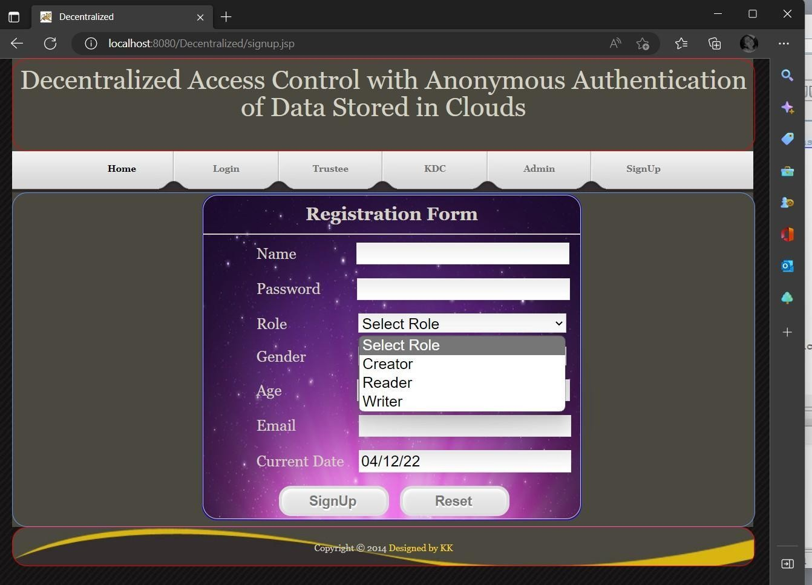

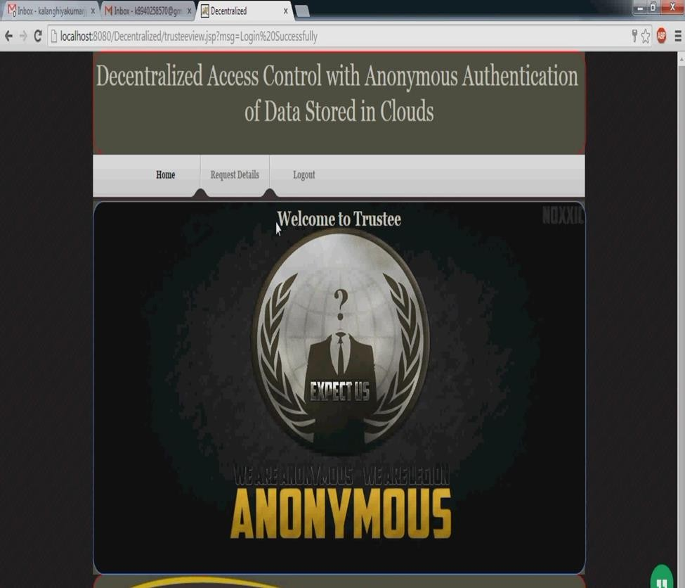

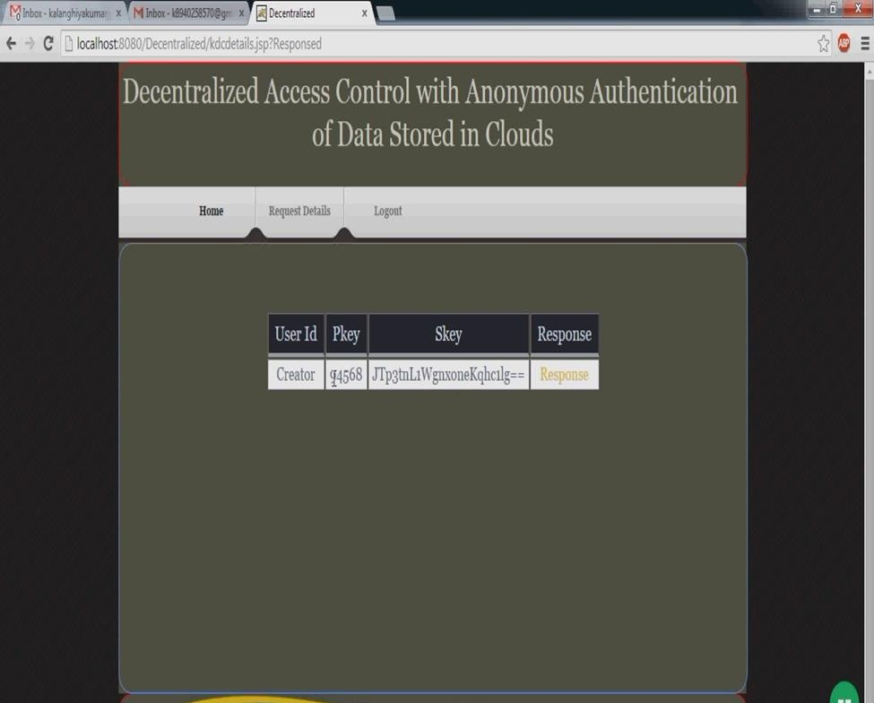

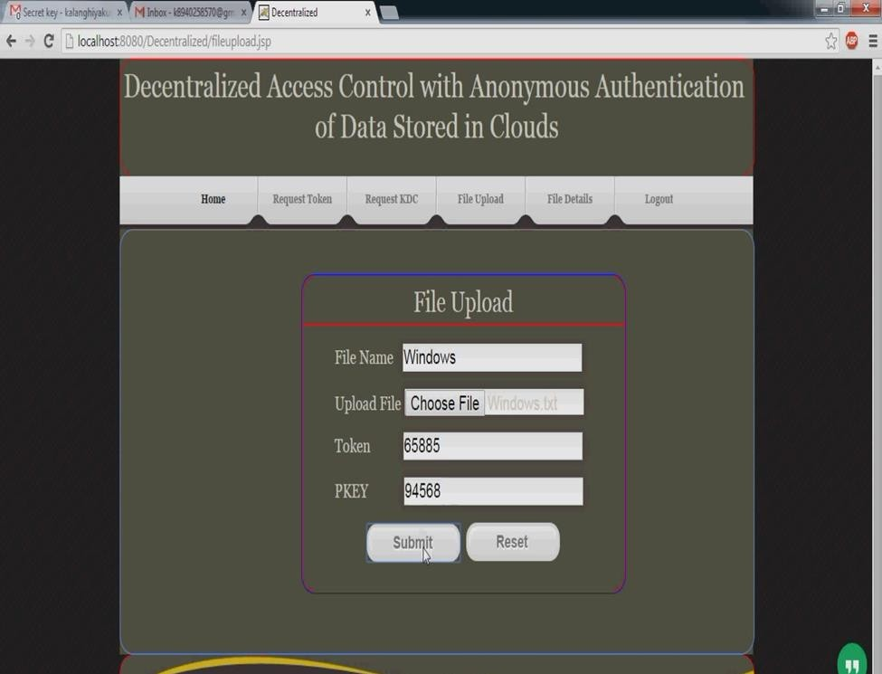

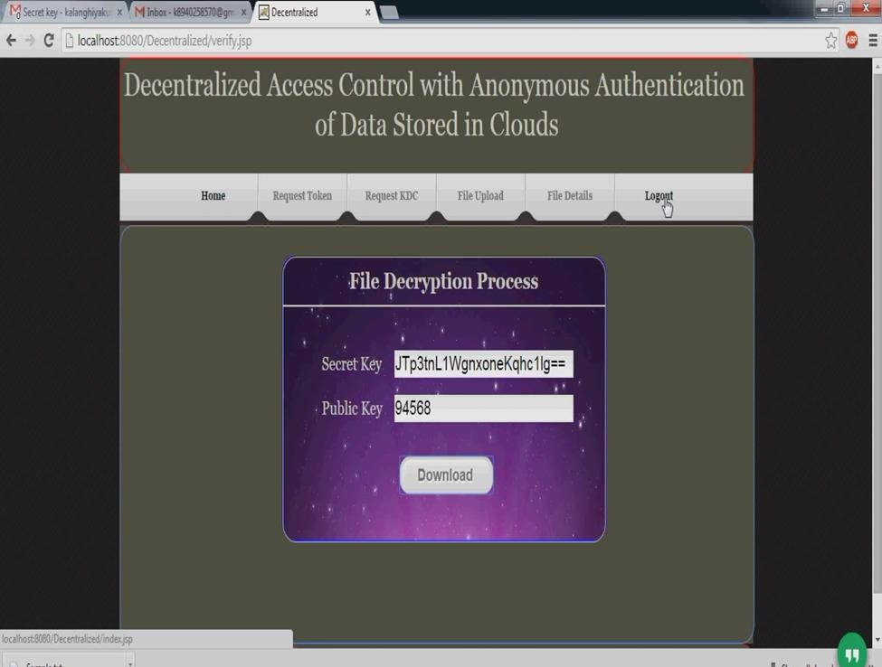

**CONCLUSION**

* + We have presented a decentralized access control technique with anonymous authentication, which provides user revocation and prevents replay attacks.
  + The cloud does not know the identity of the user who stores information, but only verifies the user’s credentials.
  + Key distribution is done in a decentralized way.
  + One limitation is that the cloud knows the access policy for each record stored in the cloud.
  + In future, we would like to hide the attributes and access policy of a user.

# BIBLIOGRAPHY

1. S. Ruj, M. Stojmenovic, and A. Nayak, “Privacy Preserving Access Control with Authentication for Securing Data in Clouds,” Proc. IEEE/ACM Int’l Symp. Cluster, Cloud and Grid Computing, pp. 556-563, 2012.2.
2. C. Wang, Q. Wang, K. Ren, N. Cao, and W. Lou, “Toward Secure and Dependable Storage Services in Cloud Computing,” IEEE Trans. Services Computing, vol. 5, no. 2, pp. 220-232, Apr.-Jun 2012.3.
3. J. Li, Q. Wang, C. Wang, N. Cao, K. Ren, and W.Lou, “Fuzzy Keyword Search Over Encrypted Data
4. D.R. Kuhn, E.J. Coyne, and T.R. Weil, “Adding Attributes to Role-Based Access Control,”IEEE Computer, vol. 43, no. 6, pp. 79-81, June 2010.5.
5. H.K. Maji, M. Prabhakaran, and M. Rosulek, “Attribute-Based Signatures: Achieving Attribute-Privacy and Collusion-Resistance,” IACR Cryptology ePrint Archive, 2008.6.
6. H.K. Maji, M. Prabhakaran, and M. Rosulek, “Attribute Based Signatures,” Topics in Cryptology- CT-RSA, vol. 6558, pp. 376-392, 2011.7.
7. K. Yang, X. Jia, and K. Ren, “DAC-MACS: Effective Data Access Control for Multi-Authority Cloud Storage Systems,” IACR Cryptology ePrint Archive, p. 419, 2012.8.
8. A.B. Lewko and B. Waters, “Decentralizing Attribute- Based Encryption,” Proc. Ann. Int’l Advances in Cryptology (EUROCRYPT), pp. 568-588, 2011